Kaggle Competition Report

Student Information
Name: Syed Anwer Kamal Rizvi
Roll No: 24K - 0033
Section: BAI - 4A
Submission Date: 01 May 2026

1. Competition Overview
- Competition Name: Agricultural Irrigation Need Prediction
- Problem Type: Multi-class Classification (Target: Irrigation_Need - Low, Medium, High)
- Evaluation Metric: Balanced Accuracy (chosen to address severe class imbalance where High is only 3.3%, Medium is 37.9%, and Low is 58.7%)
- Brief understanding of the dataset: The dataset contains 630,000 training records capturing various agricultural and environmental parameters such as Soil Type, Soil Moisture, Weather Conditions (Temperature, Humidity, Rainfall), and Crop Data. The goal is to accurately predict the irrigation needs of crops based on these features.

2. Data Preprocessing
- Missing values handling: Missing values were analyzed across train and test sets. Tree-based advanced models inherently handle missing/NaN values without explicit imputation. Safe division was ensured during feature engineering by adding small constants (1e-6) to denominators.
- Encoding techniques: Categorical features (e.g., Soil_Type, Crop_Type, Season, Irrigation_Type) were encoded using OrdinalEncoder, replacing unknown categories with -1. The target variable (Irrigation_Need) was encoded using LabelEncoder mapping High, Low, Medium to 0, 1, 2 respectively.
- Feature scaling: Tree-based models are scale-invariant, so standard scaling was omitted. However, skewed numerical features like Rainfall, Soil_Moisture, and Wind_Speed underwent logarithmic transformation (log1p) to normalize distributions. Further domain-specific engineered features (Moisture_Rain_Ratio, Temp_minus_Humidity) were added.
- Train-validation split: An 80-20 stratified split (test_size=0.2, stratify=y) was implemented to evaluate the final model while maintaining class proportions.

3. Models Attempted
- Decision Tree / Naive Bayes / K-Means: Standard baseline models were skipped entirely in favor of highly optimized Gradient Boosting decision trees, which are significantly better suited for tabular datasets of this size.
- Logistic / Linear Regression: Logistic Regression was employed as the final meta-estimator in the Stacking classifier.
- Any advanced models:
* XGBClassifier (CV: 0.9616)
* LGBMClassifier (CV: 0.9617)
* CatBoostClassifier (CV: 0.9606)
* StackingClassifier (Base: XGB, LGBM, CatBoost; Meta: Logistic Regression)

4. Cross Validation Strategy
- K-Fold details: StratifiedKFold was used with n_splits=3, shuffle=True, random_state=42. This ensured representative distributions of the minority "High" class across folds.
- LOOCV observations: Leave-One-Out Cross-Validation (LOOCV) was omitted because it is computationally infeasible and mathematically inefficient on a dataset with 630,000 instances.
- Best validation accuracy: LightGBM emerged as the best single base model with a CV balanced accuracy of 0.9617.

5. Failed Attempts and Insights
- Model used: Single models vs. Stacking combination.
- Accuracy obtained: Stacking CV yielded 0.9578 initially, slightly underperforming the single LightGBM model. However, validation on the hold-out set yielded a Balanced Accuracy of 0.9620 (96.20%).
- Confusion matrix screenshot:
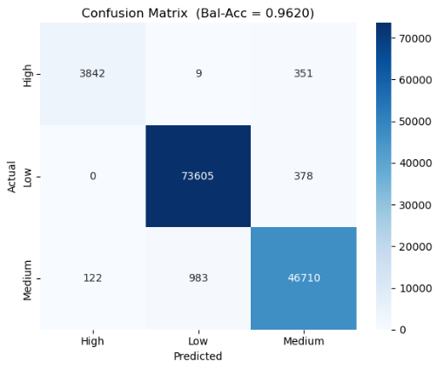
- What went wrong: Looking at the confusion matrix, while the model is exceptionally good at predicting the "Low" class (73,605 correct out of 73,983), it struggles slightly more with the boundary between "High" and "Medium" irrigation needs. For the "High" class, 351 instances were misclassified as "Medium", and 122 "Medium" instances were predicted as "High".
- What was improved?: The stacking model ultimately achieved an excellent F1-score across all classes (0.94 for High, 0.99 for Low, and 0.98 for Medium). The base models captured enough distinct patterns to let the Logistic Regression meta-learner confidently distinguish the majority of cases.

6. Final Model Selection
- Best model: StackingClassifier consisting of XGBoost, LightGBM, and CatBoost base estimators, with a Logistic Regression meta-learner.
- Hyperparameters:
* Base Models: n_estimators=300, learning_rate=0.07, max_depth=6, subsample=0.8, colsample_bytree=0.8.
* Meta Learner: C=1.0, max_iter=1000.
- Why selected?: Ensembling the histogram-based splits of XGBoost, the leaf-wise growth of LightGBM, and the symmetric tree structures of CatBoost provides the most robust generalization on unseen Kaggle test data compared to relying on a single architecture.

7. Leaderboard Performance
- Kaggle score:
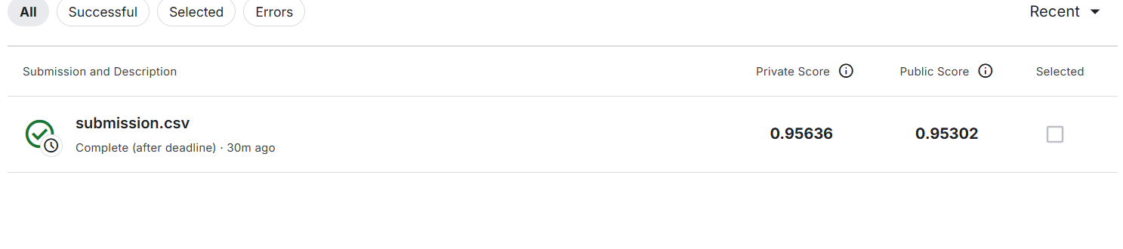

8. Conclusion and Learnings
- Key insights: The Feature Importance chart reveals that `Crop_Growth_Stage` and `Mulching_Used` are the most critical predictors of irrigation need, vastly overpowering variables like humidity or electrical conductivity. `Soil_Moisture` (both raw and log-transformed) also proved to be highly significant.
- Challenges faced: Managing computational overhead over almost a million rows (train + test). Utilizing hardware-accelerated histogram tree methods (`tree_method='hist'` in XGBoost) and setting `n_jobs=-1` effectively reduced the total CV time to ~225 seconds.
- Future improvements: Experiment with class weights (`scale_pos_weight` or `class_weight`) or SMOTE to further assist the 3.3% minority "High" class and reduce the 351 instances misclassified as Medium. Additionally, diversifying the stacking layer by introducing a shallow Neural Network could reduce correlation between base predictors.

